**Lab 2**

**GPS**

**Mohamed Khaled Shehata ID: 4783**

# *1.1) Global Positioning System History*

GPS has its origins in the Sputnik era when scientists were able to track the satellite with shifts in its radio signal known as the "Doppler Effect." The United States Navy conducted satellite navigation experiments in the mid 1960's to track US submarines carrying nuclear missiles. With six satellites orbiting the poles, submarines were able to observe the satellite changes in Doppler and pinpoint the submarine's location within a matter of minutes.

In the early 1970's, the Department of Defense (DoD) wanted to ensure a robust, stable satellite navigation system would be available. Embracing previous ideas from Navy scientists, the DoD decided to use satellites to support their proposed navigation system. DoD then followed through and launched its first Navigation System with Timing and Ranging (NAVSTAR) satellite in 1978. The 24 satellite system became fully operational in 1993.Today, GPS is a multi-use, space-based radionavigation system owned by the US Government and operated by the United States Air Force to meet national defense, homeland security, civil, commercial, and scientific needs. GPS currently provides two levels of service: Standard Positioning Service (SPS) which uses the coarse acquisition (C/A) code on the L1 frequency, and Precise Positioning Service (PPS) which uses the P(Y) code on both the L1 and L2 frequencies. Access to the PPS is restricted to US Armed Forces, US Federal agencies, and selected allied armed forces and governments. The SPS is available to all users on a continuous, worldwide basis, free of any direct user charges. The specific capabilities provided by SPS are published in the Global Positioning System Performance Standards and Specifications.

***1.2) GPS’ Applications***

**Aviation**

**Marine**

**Farming**

**Science**

**Surveying**

**Military**

**Financial Services**

**Telecommunications**

**Heavy Vehicle Guidance**

**Road Transportation**

***1.3) What is modulation type used in GPS?***

Binary Phase Shift Keying (BPSK), some satellites use quadrature amplitude modulation (QAM).

***1.4) Spectrum frequency band used in military and civilian applications.***

Civilian Applications use spectrum = 1.57GHZ

Military applications use L1 & L2 spectra = 1.22GHZ

***1.5) Multiple access used in GPS***

Two types of multiple access techniques are currently used in GNSS: Frequency Division Multiple Access (FDMA) and Code Division Multiple Access (CDMA).

***1.6) GPS’ Accuracy***

How accurate is GPS for speed measurement?

As with positioning, the speed accuracy of GPS depends on many factors.The government provides the GPS signal in space with a global average user range rate error (URRE) of ≤0.006 m/sec over any 3-second interval, with 95% probability.This measure must be combined with other factors outside the government's control, including satellite geometry, signal blockage, atmospheric conditions, and receiver design features/quality, to calculate a particular receiver's speed accuracy.

How accurate is GPS for timing?

GPS time transfer is a common method for synchronizing clocks and networks to Coordinated Universal Time (UTC). The government distributes UTC as maintained by the U.S. Naval Observatory (USNO) via the GPS signal in space with a time transfer accuracy relative to UTC(USNO) of ≤40 nanoseconds (billionths of a second), 95% of the time. This performance standard assumes the use of a specialized time transfer receiver at a fixed location.

Is military GPS more accurate than civilian GPS?

The user range error (URE) of the GPS signals in space is actually the same for the civilian and military GPS services. However, most of today's civilian devices use only one GPS frequency, while military receivers use two.Using two GPS frequencies improves accuracy by correcting signal distortions caused by Earth's atmosphere. Dual-frequency GPS equipment is commercially available for civilian use, but its cost and size has limited it to professional applications.With augmentation systems, civilian users can actually receive better GPS accuracy than the military.

Doesn't the government degrade civilian GPS accuracy?

No. During the 1990s, GPS employed a feature called Selective Availability that intentionally degraded civilian accuracy on a global basis.In May 2000, at the direction of President Bill Clinton, the U.S. government ended its use of Selective Availability in order to make GPS more responsive to civil and commercial users worldwide.

***1.7) GPS’ Segments***

Space segment:

There are 24 operational GPS satellites at altitude 20200 km and inclination 55o

each of them circles earth twice daily in one of 6 equally space orbits.

    At a given moment at least 4 satellites are required to determine the position of a point

    The one-way signals that give the current GPS satellite position and time

Control segment:

The control segment consists of worldwide monitor and control stations that maintain

the satellites in their proper orbits through occasional command maneuvers, and

adjust the satellite clocks. It tracks the GPS satellites, uploads updated navigational

data, and maintains health and status of the satellite constellation

Its job is tracking satellites, analyzing their transmission and sending commands

through monitor stations, master control and ground antenna.

User segment:

The user segment consists of the GPS receiver equipment, which receives the

signals from the GPS satellites and uses the transmitted information to calculate the

user's three-dimensional position and time.

***1.8) Coarse Acquisition (C/A)***

C/A (Coarse Acquisition) code modulates the L1(1.57 GHz) carrier. It repeats every 1023 bits(code rate = 1.023 Mchip/sec and code repeats after 1023 chips) and modulatesat a 1MHz rate. Each satellite has a unique pseudo-random code. The C/A code is the basis for civilian GPS use.

***1.9) P-Code***

It repeats on a seven day cycle(6.19*102 chips rate = 10.23 Mcps) and modulates both the L1 and L2 carriers at a 10MHz rate. This code is intended for military users and can be encrypted. When it's encrypted it's called "Y" code. Since P code is more complicated than C/A it's more difficult for receivers to acquire. That's why many military receivers start by acquiring the C/A code first and then move on to P code.

***1.10) Position Calculating***

A GPS receiver calculates its position by precisely timing the signals sent by GPS satellites high above the Earth. Each satellite continually transmits messages that include the time the message was transmitted and the satellite position at the time of message transmission.The receiver uses the messages it receives to determine the transit time of each message and computes the distance to each satellite using the velocity of light.

At least 3 satellites are required to calculate positioning(2D).

At least 4 satellites are required to calculate positioning(3D).

# *1.11) Sources of Error:*

* Atmospheric Interference
* Calculation and rounding errors
* Ephemeris (orbital path) data errors
* Multi-path effects
* Radio interference or jamming
* Satellite signal blockage due to buildings, bridges, trees, etc.

# *1.12) GPS Time*

The precise measurement of time is at the heart of every GPS receiver. The distances between satellite and receiver, used to calculate position, are determined by measuring the transit times of the satellite signals to the receiver. An error of 1 nanosecond in the transit time translates into an error of 30cm in the distance. The GPS satellite constellation uses its own precise measure of time called GPS time with each satellite having its own, on-board set of atomic clocks. Satellites can thus be viewed as very accurate flying clocks.

By tracking a GPS satellite, a receiver can record the time differences between its own receiver clock and the satellite clock.

# *1.13) Nav Message:*

The NAV message is also known as the GPS message. The navigation message is made up of three major components. The first part contains the GPS date and time, plus the satellite’s status and an indication of its health. The second part contains orbital information called ephemeris data and allows the receiver to calculate the position of the satellite. The third part, called the almanac, contains information and status concerning all the satellites; their locations and PRN numbers.

 It includes some of the information the receivers need to determine positions. Today, there are several NAV messages being broadcast by GPS satellites, but we will look at the oldest of them first. The legacy NAV (NAV) message continues to be one of the mainstays on which GPS relies. The NAV code is broadcast at a low frequency of 50 Hz on both the L1 and the L2 GPS carriers. It carries information about the location of the GPS satellites called the ephemeris and data used in both time conversions and offsets called clock corrections.

The entire Navigation message, the *Master Frame*, contains 25 frames. Each frame is 1500 bits long and is divided into five subframes. Each subframe contains 10 words and each word consists of 30 bits. Therefore, the entire Navigation message contains 37,500 bits and at a rate of 50 bits-per-second takes 12½ minutes to broadcast and to receive on a completely cold start. In other words, getting the whole thing is not instantaneous. It does take a bit of time for the receiver to update its Navigation Message.

# *1.14)L5 Interface:*

L5 is the third civilian GPS signal, designed to meet demanding requirements for safety-of-life transportation and other high-performance applications.Its name refers to the U.S. designation for the radio frequency used by the signal (1176 MHz).L5 is broadcast in a radio band reserved exclusively for aviation safety services. It features higher power, greater bandwidth, and an advanced signal design.Future aircraft will use L5 in combination with L1 C/A to improve accuracy (via ionospheric correction) and robustness (via signal redundancy).In addition to enhancing safety, L5 use will increase capacity and fuel efficiency within U.S. airspace, railroads, waterways, and highways.Beyond transportation, L5 will provide users worldwide with the most advanced civilian GPS signal. When used in combination with L1 C/A and L2C, L5 will provide a highly robust service. Through a technique called trilaning, the use of three GPS frequencies may enable sub-meter accuracy without augmentations, and very long range operations with augmentations.In 2009, the Air Force successfully broadcast an experimental L5 signal on the GPS IIR-20(M) satellite. The first GPS IIF satellite with a full L5 transmitter launched in May 2010.In April 2014, the Air Force began broadcasting civil navigation (CNAV) messages on the L5 signal. However, L5 remains pre-operational and should be employed at the user's own risk until it is declared operational.

# *2.1) GPGLL:*

# This log contains latitude and longitude of present vessel position, time of position fix     and status.The GPGLL log outputs these messages without waiting for a valid almanac. Instead, it uses a UTC time, calculated with default parameters. In this case, the UTC time status  is set to WARNING since it may not be one hundred percent accurate. When a valid almanac is available, the receiver uses the real parameters. Then the UTC time status is set to VALID.

# GPGSV:

# This log contains the number of GPS SVs in view, PRN numbers, elevation, azimuth and SNR value. Each message includes up to four satellites. If there are more than four satellites in view, additional messages are transmitted. The total number of messages and the message number are included in each message.The GPGSV log outputs these messages without waiting for a valid almanac. Instead, it uses a UTC time, calculated with default parameters. In this case, the UTC time status is set to WARNING since it may not be one hundred percent accurate. When a valid almanac is available, the receiver uses the real parameters. Then the UTC time status is set to VALID.

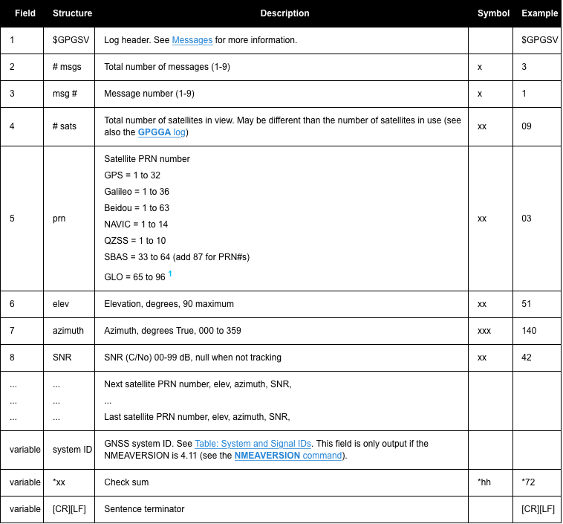

***2.2)Accuracy***

I guess they are not accurate as there were lots of interference altering the signal.

***2.3)UART***

Printing Rate:

  Delay_ms(new value);

  UART1_Write_Text("\r\n");

Rate of transmission :

baud rate :UART1_Init(9600);

***2.4) Change initial parameters for UART***

UART3_Init_Advanced(9600, _UART_8_BIT_DATA, _UART_NOPARITY, _UART_ONE_STOPBIT, &_GPIO_MODULE_USART3_PD89);

***3)Mini-Simulations***

**clc;**

**clear all;**

**close all;**

**%%%%%%%%%%%%%%%%%%%%%%%C/A code with phase tap(3,8)%%%%%%%%%%%%%%%%%%%%%%%**

**%Register1**

**SR1=[1 1 1 1 1 1 1 1 1 1];%initial fill of first shift register**

**SR1_code=zeros(1,1023);% just initialization of the o/p code vector of SR1 and the values have to be changed in the following for loop**

**for i=1:1023**

**temp = xor(SR1(3),SR1(10));**

**SR1_code(i) = SR1(10);**

**SR1 = circshift(SR1,1);**

**SR1(1) = temp;**

**end**

**%Register2**

**SR2=[1 1 1 1 1 1 1 1 1 1];%initial fill of second shift register**

**SR2_code=zeros(1,1023);   % just initialization of the o/p code vector of SR2 and the values have to be changed in the following for loop**

**for i=1:1023**

**temp = xor(SR2(2), SR2(3));**

**temp = xor(temp , SR2(6));**

**temp = xor(temp, SR2(8));**

**temp = xor(temp, SR2(9));**

**temp = xor(temp, SR2(10));**

**SR2_code(i) = xor(SR2(3),SR2(8));**

**SR2 = circshift(SR2,1);**

**SR2(1) = temp;**

**end**

**CA_code_1=xor(SR1_code,SR2_code);    % xor between G1 and G2 to get C/A code_1**

**%autocorrelation calculation**

**CA_code_1=CA_code_1';   % transpose the code**

**CA_code_1=2*CA_code_1-1;%change 1/0 to 1/-1**

**for shift=0:1022**

**shifted_code= circshift(CA_code_1,shift);            %shifted version of C/A code 1**

**autocorrelation_1(shift+1) = CA_code_1'*shifted_code;**

**end**

**figure**

**stem(autocorrelation_1)**

**grid on**

**xlabel('shifts');**

**xlim([0,1023]);**

**ylabel('value of correlations');**

**title('1023 chip Gold code(3,8) autocorrelation')**

**%%%%%%%%%%%%%%C/A code with phase tap (2,6)%%%%%%%%%%%%%%%%%%%%%%%%%%%**

**% Register1**

**SR1=[1 1 1 1 1 1 1 1 1 1];%initial fill of first shift register**

**SR1_code=zeros(1,1023); % just initialization of the o/p code vector of SR1 and the values have to be changed in the following for loop**

**for i=1:1023**

**temp = xor(SR1(3),SR1(10));**

**SR1_code(i) = SR1(10);**

**SR1 = circshift(SR1,1);**

**SR1(1) = temp;**

**end**

**%Register2**

**SR2=[1 1 1 1 1 1 1 1 1 1];%initial fill of second shift register**

**SR2_code=zeros(1,1023);% just initialization of the o/p code vector of SR2 and the values have to be changed in the following for loop**

**for i=1:1023**

**temp = xor(SR2(2), SR2(3));**

**temp = xor(temp , SR2(6));**

**temp = xor(temp, SR2(8));**

**temp = xor(temp, SR2(9));**

**temp = xor(temp, SR2(10));**

**SR2_code(i) = xor(SR2(2),SR2(6));**

**SR2 = circshift(SR2,1);**

**SR2(1) = temp;**

**end**

**CA_code_2=xor(SR1_code,SR2_code);             % xor G1 and G2 to get C/A code_2**

**% autocorrelation calculation**

**CA_code_2=CA_code_2';   % transpose the code**

**CA_code_2=2*CA_code_2-1;%change 1/0 to 1/-1**

**for shift=0:1022**

**shifted_code= circshift(CA_code_2,shift);            %shifted version of C/A code 1**

**autocorrelation_2(shift+1) = CA_code_2'*shifted_code;**

**end**

**figure**

**stem(autocorrelation_2)**

**grid on**

**xlabel('shifts');**

**xlim([0,1023]);**

**ylabel('value of correlations');**

**title('1023 chip Gold code(2,6) autocorrelation')**

**%%%%%%%%%%%%Cross Correlation between first and second C/A codes %%%%%%%%%%**

**for shift=0:1022**

**shifted_code= circshift(CA_code_2,shift);            %shifted version of C/A code 1**

**cross_correlation(shift+1) = CA_code_1'*shifted_code;**

**end**

**figure**

**stem(cross_correlation)**

**grid on**

**xlabel('shifts');**

**xlim([0,1022]);**

**ylabel('value of correlations');**

**title('Gold code(3,8)and Gold code(2,6) crosscorrelation')**



